Software Requirements Specification Template

Children Monitoring System

Software Requirements Specification

1.0

09/18/2017

Avinash Vasadi
Kavya Sri Margam
Neeraja Garigipati
Harnath Vagicharla
Vaishnavi Kalvakota
Akhila Reddy Patlolla
Lavanya Kalluri

Submitted in partial fulfilment
Of the requirements of
CSIS 44-691 Graduate Directed Project 1

Revision History

Date | Description | Author | Comments
11/30/2017 | 1.0 | Neeraja, Avinash | Developed Back end
11/30/2017 | 1.0 | Kavya, Harnath | Developed Database
11/30/2017 | 1.0 | Lavanya, Akhila,Vaishanvi | Developed Front end

Document Approval

The following Software Requirements Specification has been accepted and approved by the following:
Signature | Printed Name | Title | Date

Table of Contents

Table of Contents Page Number

- Introduction
  - Purpose 1
  - Scope
  - Definitions, Acronyms, and Abbreviations
  - References
  - Overview
- General Description 1
  - Product Perspective
  - Product Functions
  - User Characteristics
  - General Constraints
  - Assumptions and Dependencies
- Specific Requirements 1
  - External Interface Requirements 1
    - User Interfaces
    - Hardware Interfaces
    - Software Interfaces
    - Communications Interface
  - Functional Requirements 2
  - Use cases 2
  - Classes / Objects 4
  - Non-Functional Requirements 4
    - Performance
    - Reliability
    - Availability
    - Security
    - Portability
  - Inverse Requirements 4
  - Design Constraints 4
  - Logical Database Requirements 4
  - Other Requirements 4
- Design 5
  - ER Diagram 5
  - GUI 6
5. Analysis Models 8
  - Data Flow Diagram 8
  - Sequence Diagram 8
6. User Guide 9
6.1 Home Page 9
6.2 Login 10
6.3 Sign Up 11
6.4 Add Child 12
6.5 Tracking 13
6.6 Logs History 14
6.7 Trash 15
7. System Manual 15
7.1 User Administration and Support 15
7.2 Administrator role 16
7.3 Data Management 16
7.4 System Management 16
7.5 Security 17

Introduction
  - Purpose: The main purpose of this system is to provide a system for the parents to monitor their children. Through this system, parents get the location of their children so that they can track them. It also provide the record of their location history so that if they need any past locations they can go through this and monitor.
  - Scope: The system provides the location of the children based on the GPS but it cannot provide any other information like it cannot show you the children, cannot provide the information about the activities of the children.
  - Definitions, Acronyms, and Abbreviations:
GPS: Global Positioning System
Children Monitoring System: The software application that serves the intended purpose.
  - References: We used so many online sources to get the grip on the project.
http://nevonprojects.com/android-geo-fencing-app-project/
http://ieeexplore.ieee.org/document/7577516/
  - Overview: Using many technologies and collaborating them in a good manner to pull
out a good output that serves the project purpose to monitor the children’s location.

General Description
  - Product Perspectives: The product is designed for monitoring children. Monitoring children activity makes parents feel good about child i.e., he/ she is safe, and they are performing their activities. This monitoring system is provided as web page, which contains monitoring device functions, database of information obtained from monitoring systems.
  - Product Functions: In this product, child is given a monitoring device, which contains GPS, and alert system, which captures the activities of child and informs to parent through web page that is accessed, by only parents. In case of emergency and danger, it sends alert message to the police too.
  - User Characteristics: Here parents are the users. They monitor their children activities who will have monitoring devices.
  - General Constraints: Web page is provided with login credentials for parents where they login with ids and each parent have unique credentials for each child.
  - Assumptions and Dependencies: We need to assume that both the parent and child should have a internet connection.

Specific Requirements:
  - External Interface Requirements:
    - User Interface: User interface with the system is based on the design and its performance. This responsibility is on UI designer who makes his more effective to attract the user.
    - Hardware Interface: Making all the devices connected with each other can make the product work effectively.
    - Software Interface: Based the coding all devices works, so coding should be done carefully and perfectly is the most important thing in any project.
    - Communication Interface: There should be communication between the team people and as a team they should work and give best output.

  - Functional Requirements:
- Should able to open the link
- Login page should allow the user to login to go into home page
- User should enter the username
- User should enter the password with combination of alphabets, numbers and special characters
- Signup page should have first name, last name, email Id, user name, password, address, phone number.
- Forgot Page should have a text field asking for email address and submit button, so that user get a link for reset password.
- Home page should contain fields like add children, track location and send share the location history
- Application home page for children will have their location on the screen wit name of location, latitude and longitude text fields on the screen.
- Parent should be able to save location history for future reference
- User should be able to logout successfully

  - USE CASES: Parents for knowing children, their activities where they go,
what they are doing, whether they are safe or not.

  - Classes/ Objects: Parents and children are main entities in this project

  - Non- Functional Requirements:
    - Performance: Each aspect of children are captured by monitoring device. So whatever may the situation their activities are monitored and information is given to parents
    - Reliability: The technical team always verifies monitoring system so if any problem occurs. They will be rectified immediately providing other monitoring system.
    - Availability: Information of monitoring system is available to parents in their account. They can access to their account anytime anywhere
    - Security: Account is provided with secure login credentials and can only logged in by parents. Data base information is protected by providing access to only authorized persons.
    - Portability: Webpage can be accessed through any device like smartphone, tablet, and laptop.

  - Inverse requirements:
We could not be able to get the location of the child if the child’s GPS is off. If anyone them does not have proper internet they will not be able to get the accurate location.

  - Design Constraints: Design constraints for web page are page size, content of page, access of location of the child is mandatory, color and format of contents, .

  - Logical Database Requirements: Computers and hard disks are required for storing data.

  - Other Requirements: Information of police and police station details are required to contact them in case of emergency.

  - Use Case Diagram :
Sign up, login and logout:
This use case is about sign up, login and logout. The user can create an account with user details like first name, last name, email ID, password and organisation name. The use can log in to the account with username and password. And, user can logout.
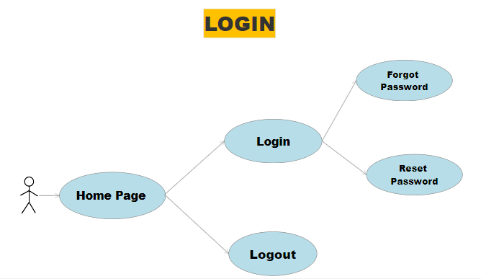
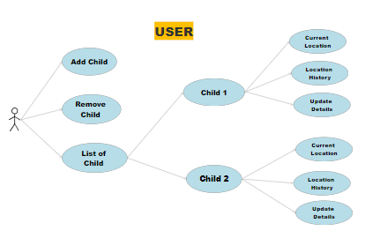

Application:
It allows user or parent to access the track the children current location, previous location history. And the user can add a children or remove a children.

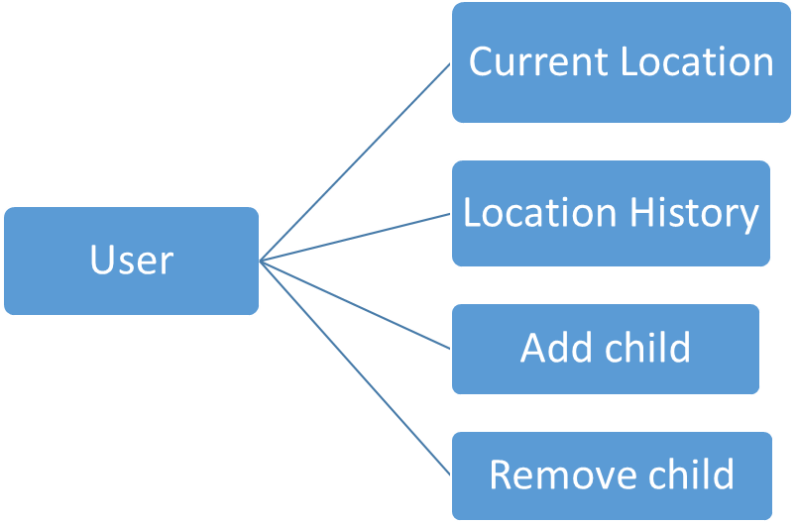
4 Design

4.1 ER diagram

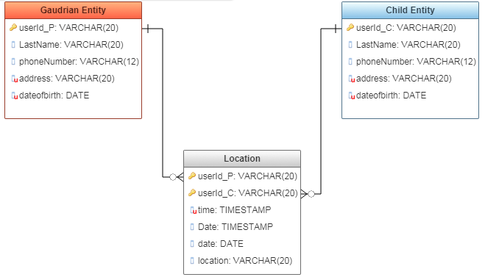

4.2 GUI

SIGNUP PAGE

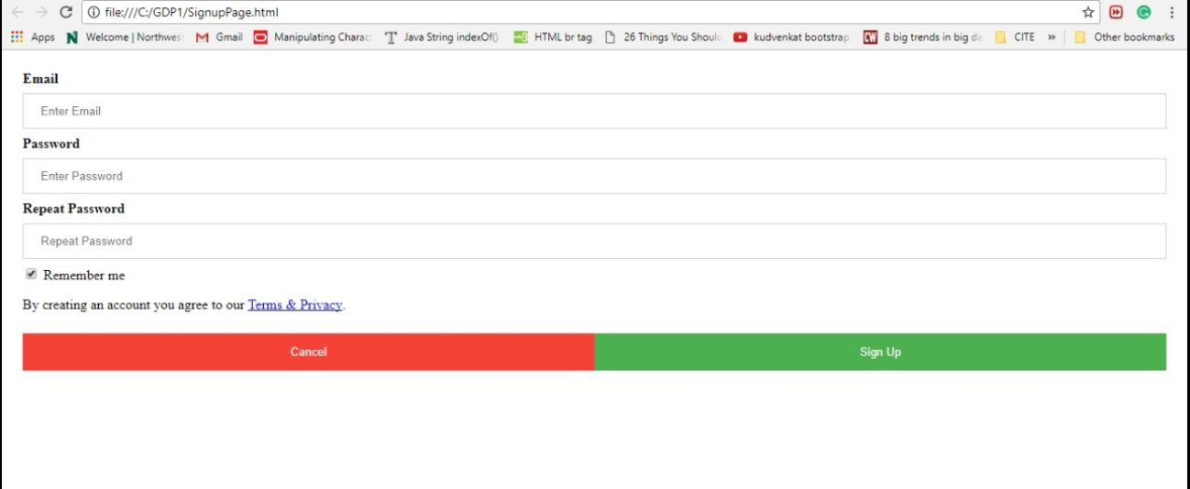

LOGIN PAGE

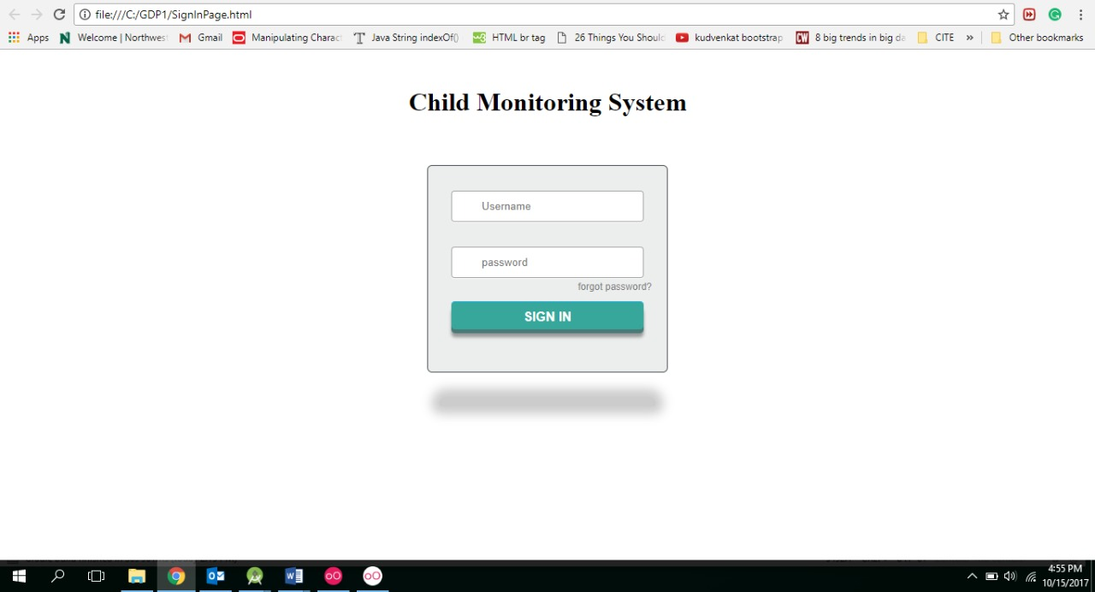

USER PAGE

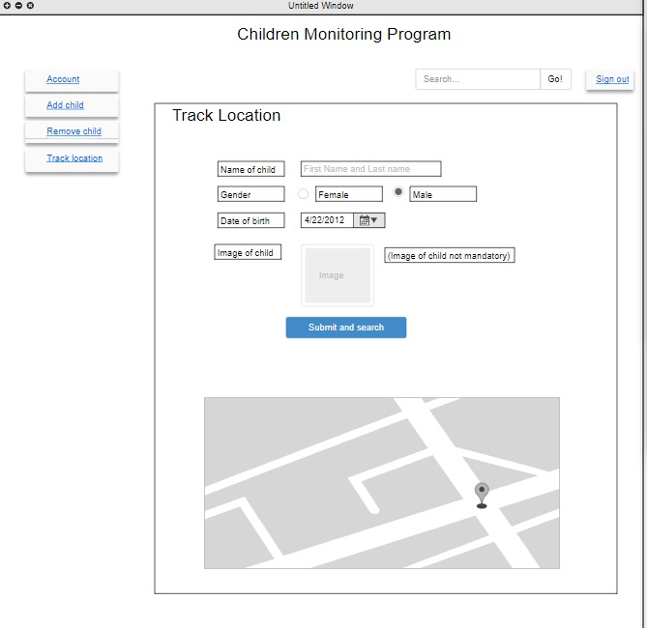

5. ANALYSIS MODEL

5.1 DATA FLOW DIAGRAM

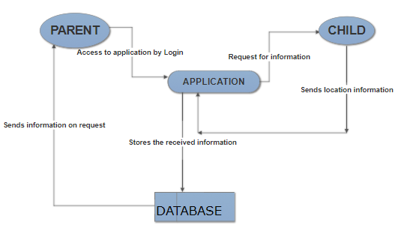
5.2 SEQUENCE DIAGRAM

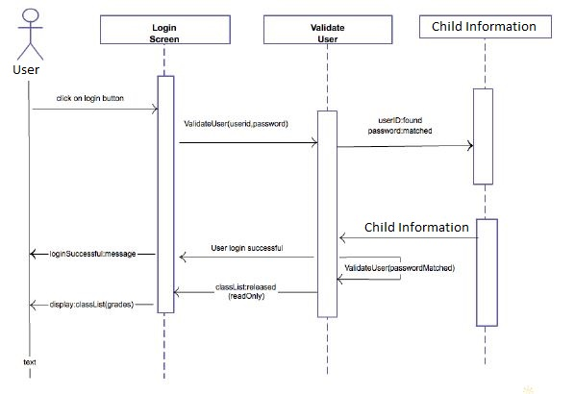
CHILDERN MONITORING SYSTEM

The main purpose of this project is to provide a system for the parents to monitor their children. Through this system, parents get the location of their children so that they can track them. It also provide the record of their location history so that if they need any past locations they can go through this and monitor.
The system provides the location of the children based on the GPS but it cannot provide any other information like it cannot show you the children, cannot provide the information about the activities of the children.

Home Page:
This page includes the introduction of the application that it describes the purpose of the system and you can find the Signup and Login, where the user can Login into their account and see the location of their children they wish to track if the user is already a registered user or else it asks you for Signup. When you click on Signup, you will be directed to the sign up page and when you click on Login, you will be directed to login page.

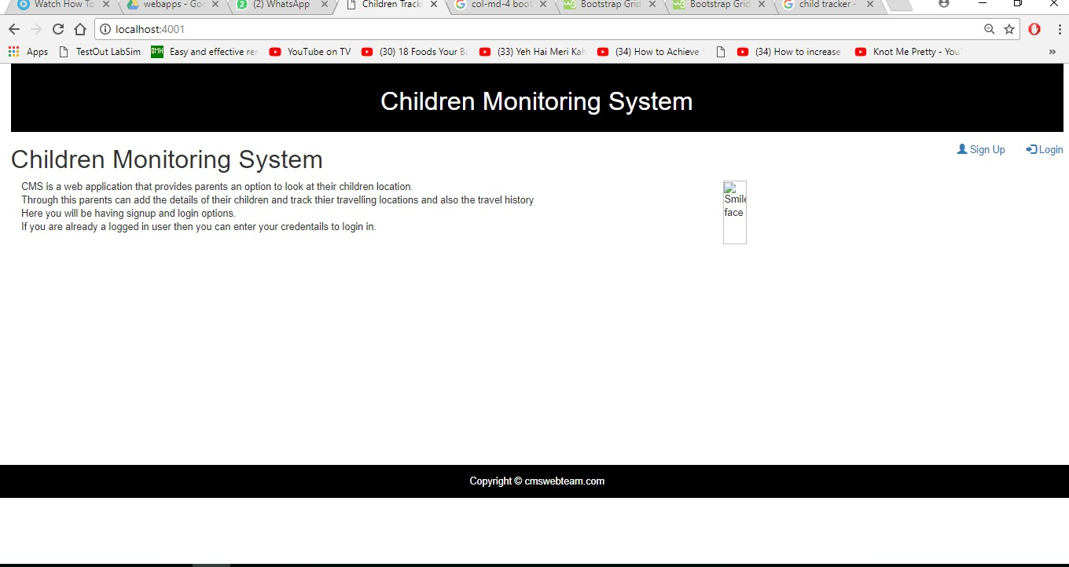

Login:
This page provides the Login functionality for a registered user. Here the user has to enter his/her username and password. Once the user enters the details the system checks the account in database and if found it allows the user to login otherwise it doesn’t allow the user. This page also provides the forgot password functionality if in case the user forgot his password he/she can use this functionality to regain the access to his account through some steps. The user can also naviagte to the Home and Signup pages in just one click.
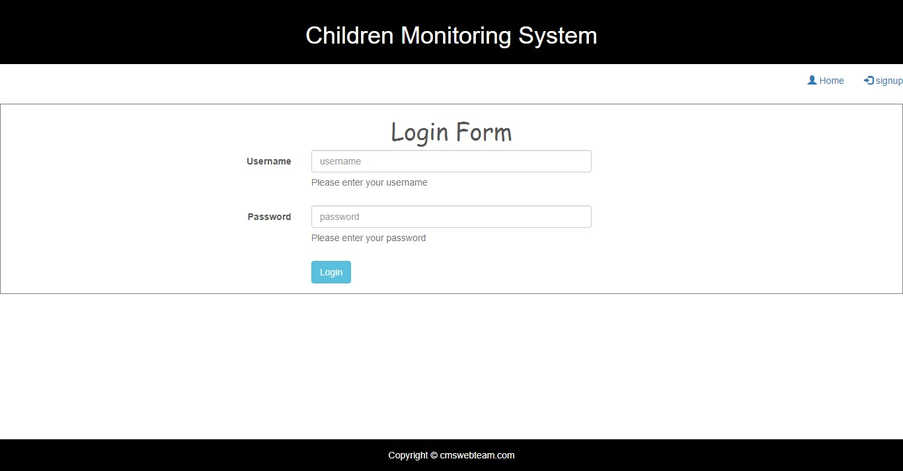

Signup:
This is the registration form for user, who wish to use this application to monitor their children. This page provides a form that asks the user for some details like First name, last name, User name, Gender, Email, Address and Phone number. After filling, all details the user has to click on submit button in order to be registered. Once you register, you can use login functionality to login to your account.

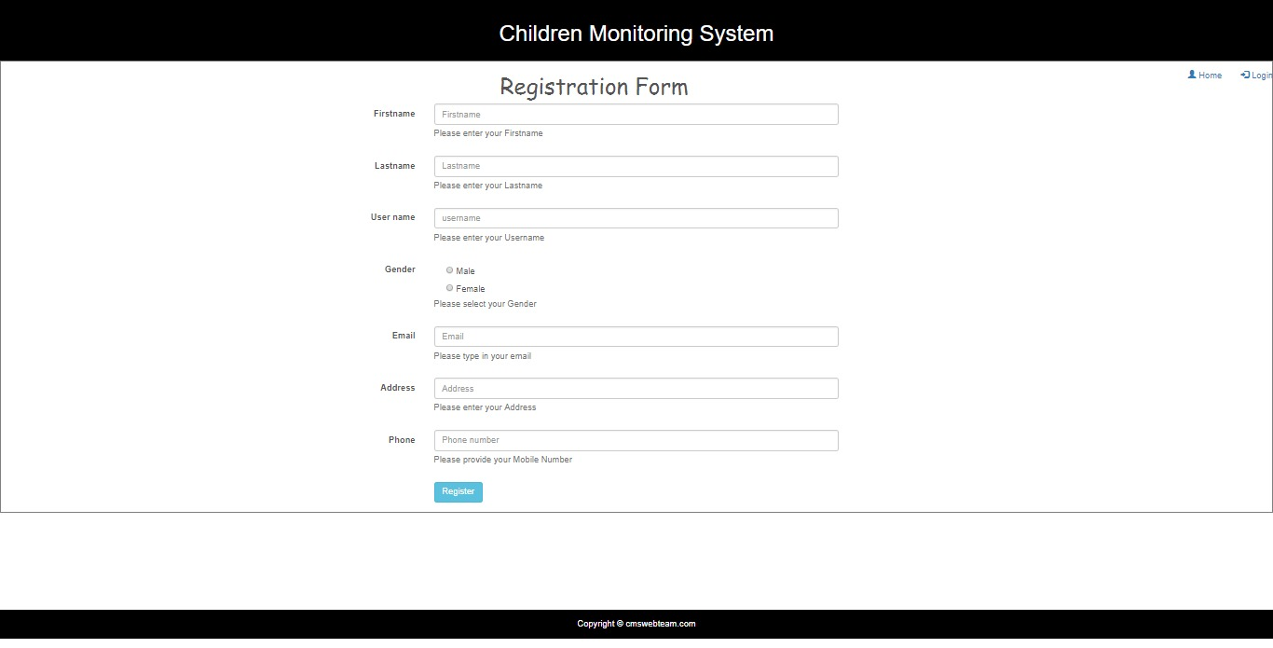

Add Child
This page of the application takes the details of the child and add them into the parents monitoring list of children. For adding the children into the monitoring system parent must complete the form in the Add child with the following details:
- Name of the child
- Gender
- Date of birth
- Image of child(not a mandatory)
- Phone Number
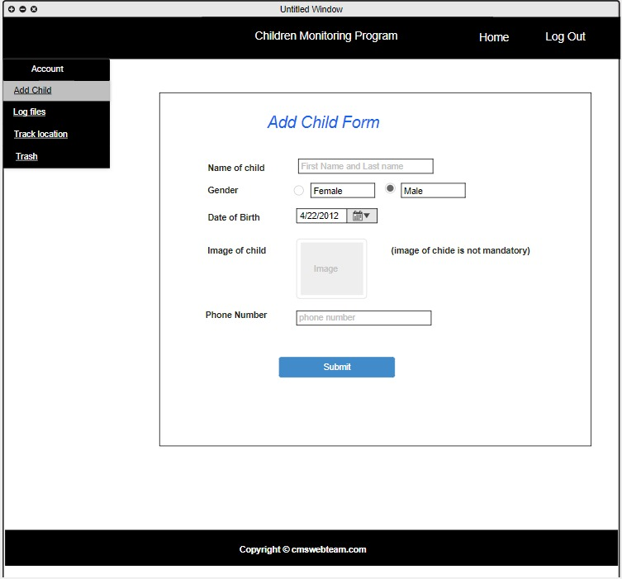

In addition, once you provide all the above details mentioned, click on the submit button to save the child details into the parents monitoring list.

Location Tracking:
In this page parent can track the current location of the child by providing their details in this page like name of the child, gender, date of birth and phone number. And once parent provides all the details and click the submit button current location of the child will be displayed in the screen.
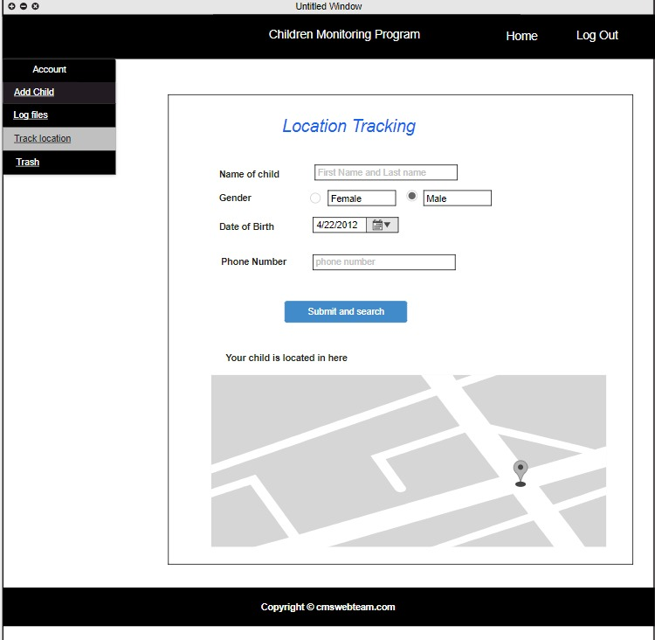

Logs of Children
This page provides the location history of the children. This provides the history of locations of last ten days. This includes the longitude and latitude of the location the children. If the there are no logs to show it gives a message like There are no files to show as of now.
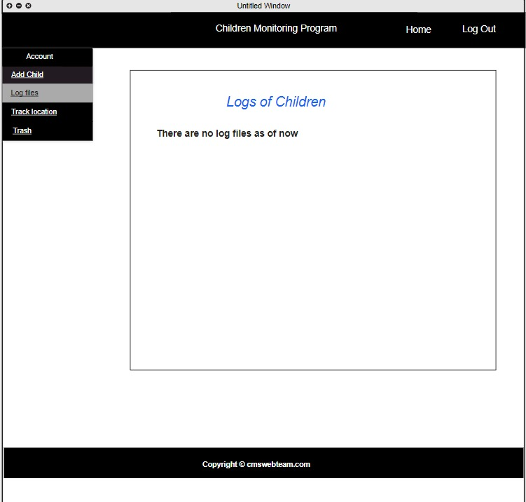

Trash
When parent deletes the logs of the child location history those deleted files be will be stored here in the trash. When the parent delete the history log accidentally, they are stored here for five days. Parent can view the log here if needed.
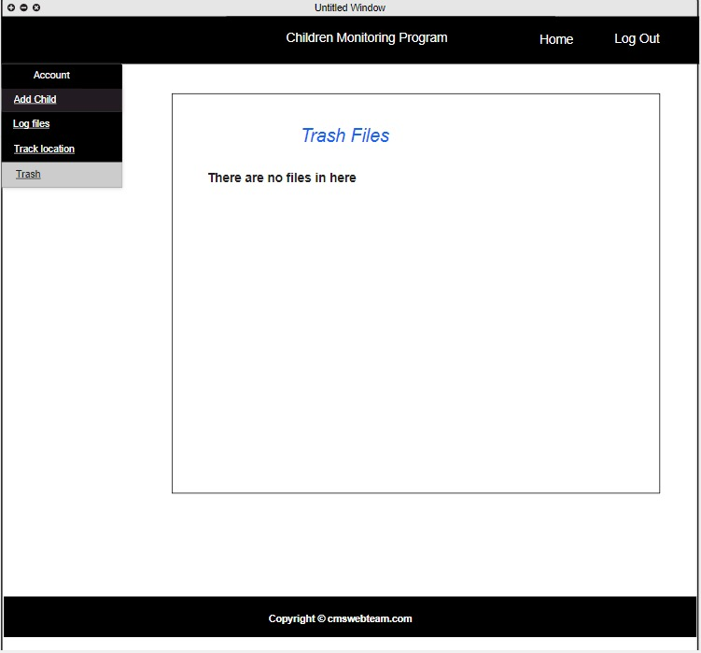

SYSTEM MANUAL:

User Adminstration and support:

Firstly, User needs to register to the application by providing his infromation that are necessary for login and account recognization like name, email address, contact information and password to secure his account. These all credentials are stored in the database like mongoDB. After he created his account is able to do tasks according to his wish like adding child to account, monitoring it, obtaining information of children. He can add as many children as he like and monitor them.

He is not only able to access his account, but also he can change his infromation stroed in database by editing his account information. He can retrive any information anytime. When he needs help regarding something it is solved by administator. For example if user forgot their password and want to set another password, then he can enter email address and the server matches this email address with the information in database, if it matches then it allows to reset password. And also if there is an error occur in the application user can contact adminstrator for help and get the support from them.

Administrator Role:

Here in this application administrator plays very important role. He acts as a supportive system to the user. He stores every detail of the user and provides it to user whenever he needs it. He maintains the database with upto date information. He keeps the user data very confidentailly that no unauthorized person can access it.

Data Management:

Entire application may fail if it is unale to manage and maintain the data in correct way. So it is very important to manage data. The application supports following features:
- Firstly When the user registers to the application all the data is stored in database.
- Every person data should be stored in separate files so that correct data is retrived for correct person.
- Each file should be given a number or name for identification of the files during retrival.
- Whenever the information of children is collected it should be stored in specific parent file in database so when data is retrived parent get his child information.
- Data integrity is maintained so that user can access data where ever he wants.

System Management:

System management involves managing parent account and collecting children information. It stores personal information of parent and child and also it has children tracking information.\

- When regetration of parent is done the server takes this information to database and stores it.
- It tracks the activities of child and provides this information to parent.
- If parent is unable to monitor their children at a time, system saves their information and parent can have it in history.
- It allows user to search information by matching the words typed by user with information in database and retrives it to user.
- It allows user to perform tasks according to his wish like add or delete child, modify personal information etc.
- It maintains separate records of each account holder and their child information.

Security:

In any application security is the most important thing. Without security no user is not able to use application and trust it. So it is necessary for the administrator to maintain security. These following securiyt features of this application

- Every information of the user is kept confidential
- No unauthorized person is able access the data of user.
- Data obtained tracking the child should be stored securily and should be accessed by only parents.
- When user try to retrive information it is necessary to make sure that authorised user accessed it, for this a security question is asked for retrival of confidential data or resetting password. This security question is set by the user during registration. So only user can answer this question and access data.
- The whole application is protected from security breaches.

